Ranoa, Julius

CSC 121 001 Computer Science I

28 September 2017 Thursday

Quiz 6 on Chapter 8: Arrays

Modify the given code to the OOP format.

Original Code by Bucky Roberts @ C++ YouTube Tutorial n.36

<https://github.com/buckyroberts/Source-Code-from-Tutorials/blob/master/C%2B%2B/35_cppBeginners.cpp>

Screenshot of Runtime:

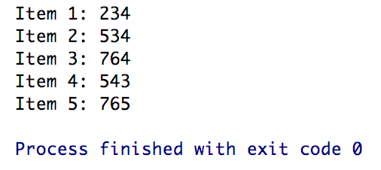

Source Code:

1. **main.cpp**
2. **IntegerArray.h**
3. **IntegerArray.cpp**